Name:__________________________________ Date: _______________ Period: ______________
Quiz 1.1 Domain & Range Quiz
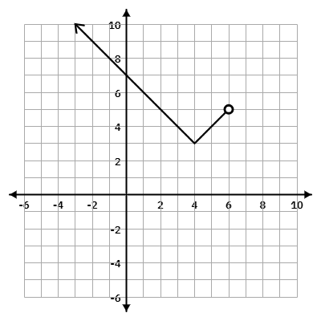
1. Write the domain and range of the function below.
Domain Inequality:_______________________

Domain Set Notation: ____________________

Domain Interval Notation: _________________

Range Inequality:_______________________

Range Set Notation: ____________________

Range Interval Notation: _________________

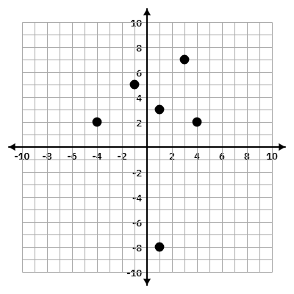
2. What is the Domain of the following graph?

3. Does the graph in #2 represent a function? Justify your answer.

Bonus:
A company’s profit, P, in thousands of dollars, from selling x items is modeled by the function $P(x)=-{{2x}^{2}+120x-500}^{}$. The company can sell a minimum of 10 items and a maximum of 50 items.
What is the domain of this function in the context of the problem?
What is the range of this function in the context of the problem?

